Laboratory 22: Amplifiers and Transformers
(Edit this document as needed)

Partner 1: John Gonzalez

Partner 2: Saaif Ahmed

Part A
Brief description of the Transformer experiment:

We build a toroidal transformer using a circular magnet and two bare wires and build a circuit allowing us to measure the input and output voltages of the transformer.

Measured resistances for the primary and secondary windings.

R_{primary} | 0.2 [Ω]
R_{secondary} | 0.2 [Ω]

With a 300kHz, 200mV source, plot of the primary and secondary voltages as a function of time, with annotations. (Discovery Board)

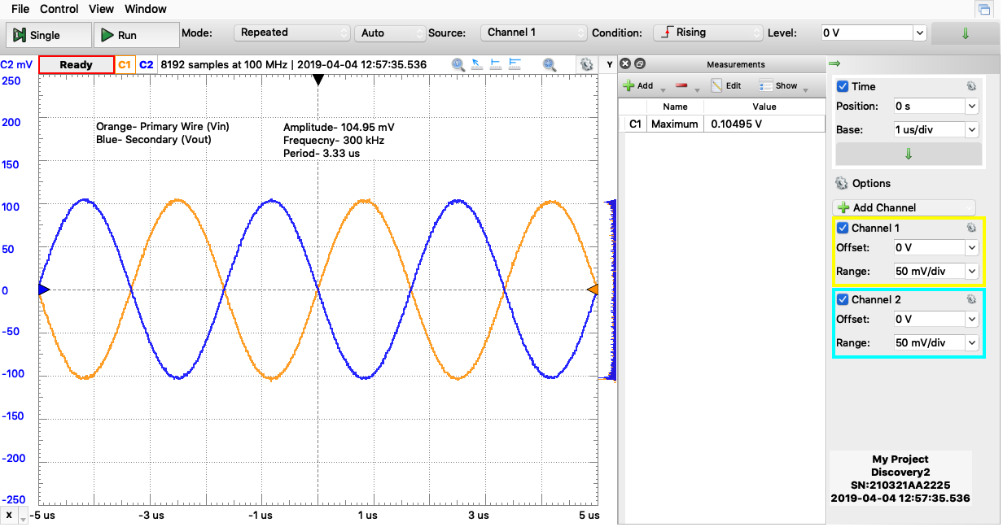

With a 300kHz, 200mV source, plot of the primary and secondary currents as a function of time, with annotations (measure across R and RLoad, applying Ohm’s Law to obtain the currents). (Discovery Board)

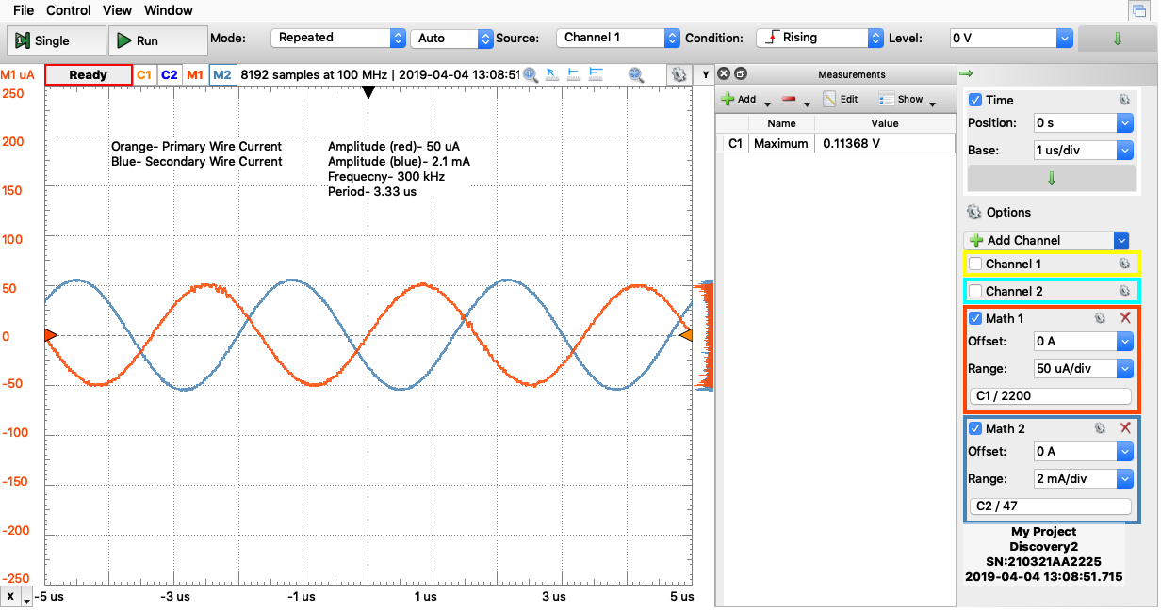
(Currents vary by a factor of 1000 because used 2.2k instead of 2.2 resistor, trends still look clean and what we would expect)

With a 300kHz, 200mV source, plot of the source and primary voltages as a function of time, with annotations. (Discovery Board)

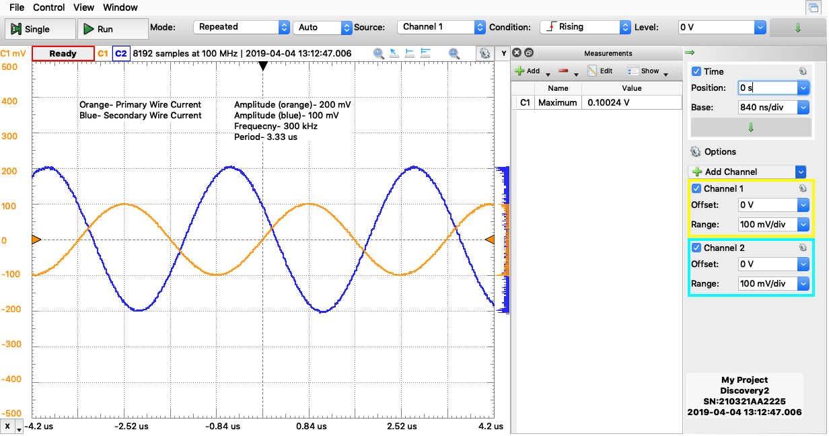
Orange-Primary
Blue- Secondary
Using the above data, estimate the turns ratio, a.

a | 1

Part B Transformer Simulation
Brief description of the Transformer simulation experiment:
Build a similar transformer circuit within LTspice and determine how accurate our physical transformer was. Analyze the voltages and current across primary and secondary and the loads of the circuits.
Estimate of primary and secondary inductances for your transformer.

L_{primary} | 2.8u[H]
L_{secondary} | 2.8u[H]

With a 300kHz, 200mV source, plot of the primary and secondary voltages as a function of time, with annotations. (LTspice)

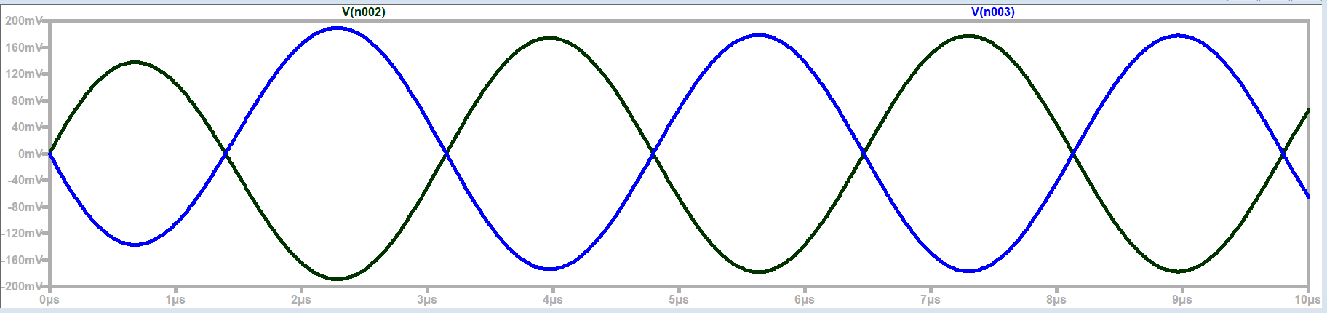
Primary= Black
Secondary= Blue
Phase Shift: 180 degrees
Ratio 1:1

With a 300kHz, 200mV source, plot of the primary and secondary currents as a function of time, with annotations. (LTspice)

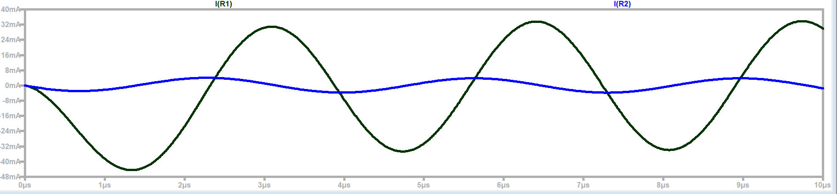

Primary= Black (32mA peak)
Secondary= Blue(4 mA peak)
Phase Shift: 90 Degrees

With a 300kHz, 200mV source, plot of the source and primary voltages as a function of time, with annotations. (LTspice)

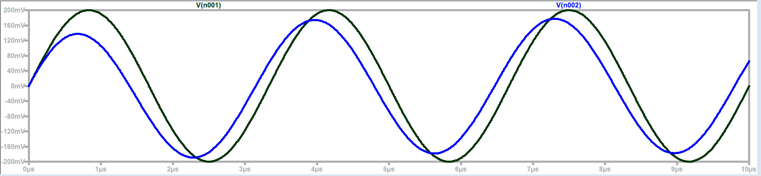
Source= Black
Primary= Blue
Phase Shift: about 45 Degrees

How do the simulation results compare to the experimental results?
The simulations trends are consistent with the experimental trends. The values are different because we used a different resistor values and the inductors were absolutely not ideal.

Calculate the input impedance (use the voltage divider expression and consider the voltage across the primary to be the load voltage for with the voltage source and source resistor). Is the value close to that expected using the ideal transformer equations?

Input Impedance: 47 ohms
The value is close within reason to the expected value using the ideal transformer equations.

Part C Joule Thief (optional)
Brief description of Joule Thief experiment:

Plot of the voltage across the LED as a function of time. (Discovery Board)

Plot of the collector-emitter as a function of time. (Discovery Board)

Plot of the base emitter voltage as a function of time. (Discovery Board)

What is the oscillation frequency for the Joule Thief circuit?

Did the LED turn on?

Part E Reflection
How well did your transformer perform?
Our transformer performed surprisingly well. Our transformer aimed to create a 1 to 1 ratio between primary and secondary. We got reasonably the same voltages across the both inductors this leading to an a value of 1. The primary and secondary were out of phase as shown by the circuit schematic and our graphs matched the ideal transformer within reasonable error.

Describe how you can estimate the inductances of the transformer windings.
The inductance of the primary and secondary were related to the coil resistance and ferrite core specifications. You can estimate the inductances based on the specification of the ferrite core, the number of windings, and the magnetic permeability. You can either look at the specifications of the ferrite core itself, or use a formula and the dimensions of the ferrite core to determine the inductance. Another option is to use an impedance bridge.

